# COMMUNITY EMPOWERMENT (SCOTLAND) ACT 2015

# FALKIRK COUNCIL ASSET TRANSFER REQUEST FORM

**IMPORTANT NOTES:**

**This is an application form which can be used to make an Asset Transfer request to Falkirk Council.**

**Any Community Body interested in making an Asset Transfer Request is advised to contact the Asset Team on** [**strategicpropertyreview@falkirk.gov.uk**](https://projecttheatre.org/) **before making the request so that we can discuss your proposal.**

**Please complete the asset transfer request form if the property/land is owned/leased/managed by Falkirk Council.**

**It is essential that you read the** [**Asset Transfer guidance**](https://www.gov.scot/binaries/content/documents/govscot/publications/advice-and-guidance/2017/01/asset-transfer-under-community-empowerment-scotland-act-2015-guidance-community-9781786527509/documents/00513211-pdf/00513211-pdf/govscot%3Adocument/00513211.pdf) **provided by the Scottish Government before making a request.**

**When completed, this form should be emailed to** [**strategicpropertyreview@falkirk.gov.uk**](mailto:strategicpropertyreview@falkirk.gov.uk) **or sent to**

**The Asset Team**

**Falkirk Council**

**4 Stadium Way**

**Falkirk**

**FK2 9EE**

**Section 1: Information about the Community Transfer Body (CTB) making the request**

* 1. Name of the CTB making the asset transfer request

SeaLock Infinity

* 1. CTB address. This should be the registered address, if you have one.

Postal address: Beancross & Newland (Newlands) Community Centre,

Montgomery Street, Grangemouth

Postcode: FK3 8QR

* 1. Contact details. Please provide the name and contact address to which correspondence in relation to this asset transfer request should be sent.

Contact name: [REDACTED]

Postal address: Beancross & Newland (Newlands) Community Centre,

Montgomery Street, Grangemouth

Postcode: FK3 8QR

Email: [REDACTED]

Telephone: [REDACTED]

 We agree that correspondence in relation to this asset transfer request may be sent by email to the email address given above. *(Please tick to indicate agreement)*

*You can ask Falkirk Council to stop sending correspondence by email, or change the email address, by telling them at any time, as long as 5 working days’ notice is given.*

* 1. Please mark an “X” in the relevant box to confirm the type of CTB and its official number, if it has one.

|  |  |  |
| --- | --- | --- |
|  | Company and its company number is …………. |  |
| X | Scottish Charitable Incorporated Organisation (SCIO) and its charity number is ……………….. | SC053502 |
|  | Community Benefit Society (BenCom) and its registered number is ……………………………… |  |
|  | Unincorporated organisation (no number) |  |

**Please attach a copy of the CTB’s constitution, articles of association or registered rules.**

Please note that under The Community Empowerment (Scotland) Act 2015, where a CTB is seeking ownership rather than a lease, the organisation must have at least 20 members. See the Scottish Government’s [Guidance for Community Transfer Bodies.](mailto:strategicpropertyreview@falkirk.gov.uk)

* 1. Has the organisation been individually designated as a community transfer body by the Scottish Ministers?

**No X**

**Yes ☐**

Please give the title and date of the designation order:

* 1. Does the organisation fall within a class of bodies which has been designated as community transfer bodies by the Scottish Ministers?

**No ☐**

**Yes X**

If yes what class of bodies does it fall within?

SCIO

1. **Information about the land and rights requested**
   1. Please identify the property/land to which this asset transfer request relates.

You should provide a street address or grid reference and any name by which the land or building is known. If you have identified the land on the relevant authority’s register of land, please enter the details listed there.

*It may be helpful to provide one or more maps or drawings to show the boundaries of the land requested. If you are requesting part of a piece of land, you must attach a map and give a full description of the boundaries of the area to which your request relates. If you are requesting part of a building, please make clear what area you require. A drawing may be helpful.*

Details of Property: 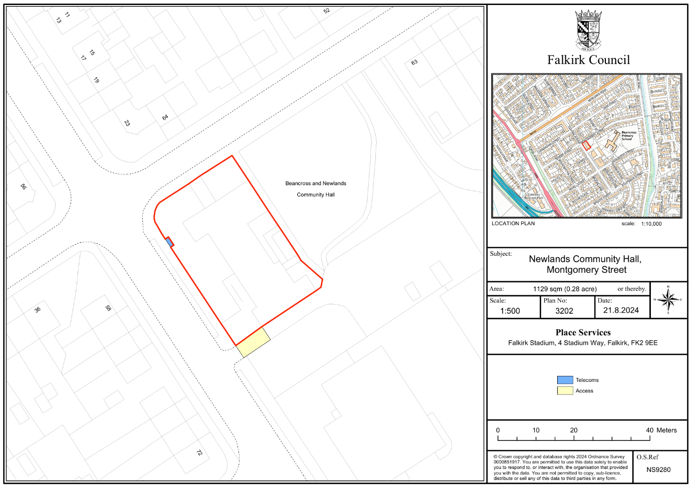

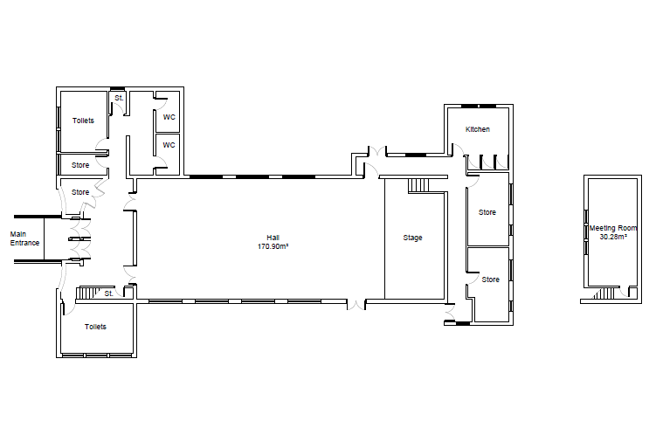

**Floorplan of the building**

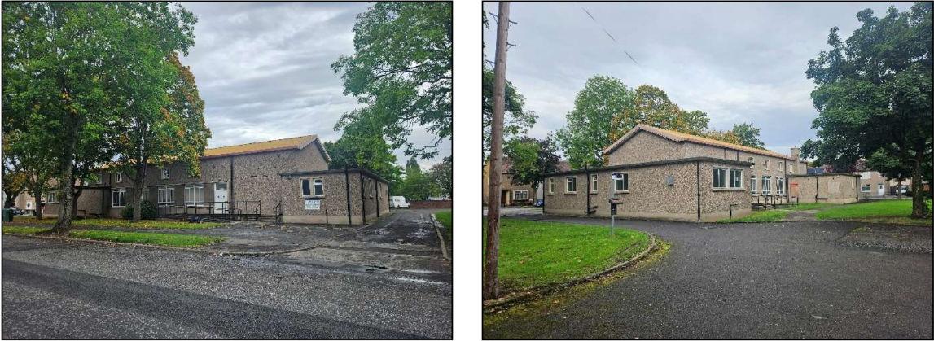

**Exterior images of the building**

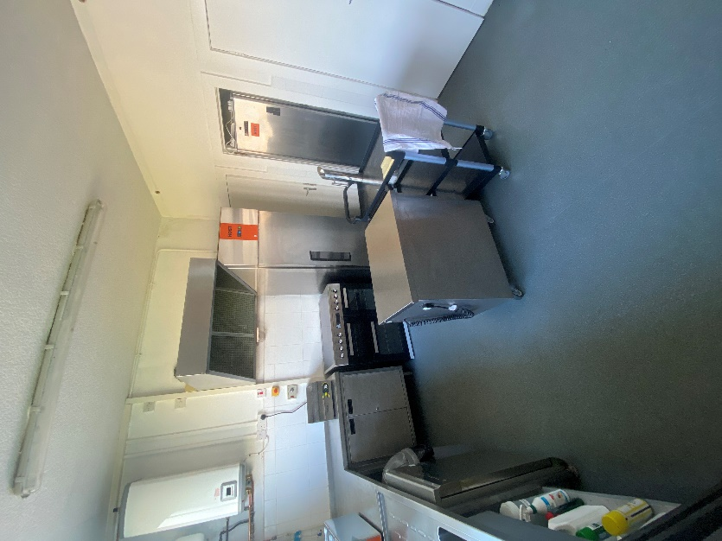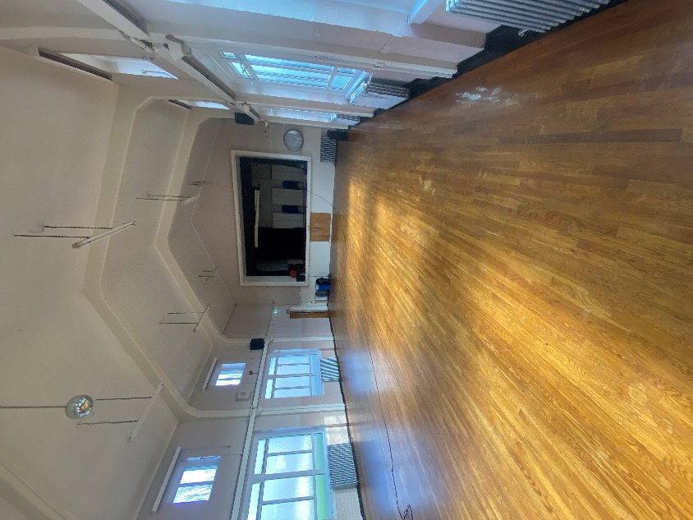

**Interior images of the main hall and kitchen**

Address: Beancross & Newland (Newlands) Community Centre,

Montgomery Street, Grangemouth

Postcode: FK3 8QR

* 1. Please provide the UPRN (Unique Property Reference Number), if known.

UPRN: 136044696

1. **Type of request, payment and conditions**
   1. Please tick what type of request is being made:

X

for ownership (under section 79(2)(a)) - go to section 3A

for lease (under section 79(2)(b)(i)) – go to section 3B

for other rights (section 79(2)(b)(ii)) - go to section 3C

3A – Request for Ownership

What price are you prepared to pay for the land requested?

Proposed price: £1

Please attach a note setting out any other terms and conditions you wish to apply to the request.

|  |
| --- |
|  |

3B – Request for Lease

What is the length of lease you are requesting?

|  |
| --- |
|  |

How much rent are you prepared to pay? Please make clear whether this is per year or per month.

Proposed rent: £ per

Please attach a note setting out any other terms and conditions you wish to be included in the lease, or to apply to the request in any other way.

|  |
| --- |
|  |

3C – Request for other Rights

What are the rights you are requesting?

|  |
| --- |
| Access rights to the car park and Access Right to Car Park for Fire Assembly Point |

Do you propose to make any payment for these rights?

**Yes ☐**

**No X**

If yes, how much are you prepared to pay? Please make clear what period this would cover, for example per week, per month, per day?

|  |
| --- |
| Proposed payment: £ per |

Please set out any other terms and conditions you wish to apply to the request.

|  |
| --- |
|  |

1. **Community Proposal** 
   1. Please set out the reasons for making the request and how the land or building will be used.

This should explain the objectives of your project, why there is a need for it, any development or changes you plan to make to the land or building, and any activities that will take place there.

|  |
| --- |
| 4.1.1 Objectives of Project  SeaLock Infinity’s Key objectives going forward is to:  • Keep the doors open to the Centre to let the community know we are open and accessible to all  • Facilitate lets and promote uses of the centre  • Engage with the community on what they want when they want it  • Identify and try out group such as Social Dancing, Youth Clubs, Community engagement events.  • Look at how the Centre can become more integrated with the local community by the name and facilities offered.  • Facilities to promote recreational activities with the object of improving the conditions of life for all individuals and groups in the area   * Offer a quality service and build a successful community centre that has a secure and viable financial future.   • We provide a happy, safe and relaxed Safe Space  • We will support and provide relief to those in need regardless of age, ill-health, disability, financial hardship or other disadvantage.  • We are working towards reducing inequality and the undertraining of equality and the importance of diversity to economic, environmental and social progress whilst creating sustainable inclusive growth.  • We want to provide a sense of belonging connecting individuals to society and reduce social isolation.  • Increase Wellbeing and encourage belonging to a group or a community to develop a stronger sense of identity to boost self-esteem.  • The organisation will promote educational initiatives, opportunities for all ages, that is adaptable to visual, auditory and kinaesthetic styles of Learning. |
| 4.1.2 Why there is a need for your Project?  The proposed plan for Community Asset Transfer will keep the proposed asset in community usage, and we will strive to make it an ongoing success.  To provide facilities for individuals or groups to gather at affordable prices to benefit the whole of Grangemouth, Falkirk District and beyond.  • To provide support with age, ill-health, disability, financial hardship, we will provide a sense of belonging connecting individuals to society and reduce social isolation.  • To be sensitive and responsive to individual’s situation and needs.  • To provide awareness and encourage volunteer participation.  • To provide awareness, encouragement and promotion of arts, heritage, culture or science.  • To provide and support our centre to be a happy, safe, relaxed and caring environment for all to enable learning and individuals and groups to develop their skills, through play and structured activities that is adaptable to visual, auditory and kinaesthetic styles of learning.  • To facilitate community development including advancement of urban regeneration with the community.  • To promote principles of sustainable development where “sustainable development” means development which meets the needs of the present without compromising the ability of future generations to meet their own needs. |
| 4.1.3 Will any Development/changes/modifications to the asset be required?  The group have been working together to form a plan of action, which has covered a variety of improvements to support the community. Our initial development plan consists of the following:   * New accessible toilet and washroom facilities to ensure the centre to ensure equal access to all in the community. * Create a welcoming Games room including pool, darts etc for all ages to use on a drop-in basis and available for private bookings. * Create and usable space like a café/barista style area to encourage individuals to walk in have a drink and some company, to meet others or just get out. During the day this can serve drinks and snacks and provide a warm space. This adaptable space can be used for many things including private bookings. This will also allow the front of the centre to be self-serving and sufficient. * Developing 2 smaller rooms to create a larger ground floor space that can be utilised for parties, exercise classes, community café and more and supplement and offer alternatives to our Main Hall. * Partitioning Stage area that has separate access from the Main Hall this can become a space for dance classes, meeting and offer alternative booking space whilst still maintaining the option of performances and groups to open up the stage for productions and concerts, dances etc. * It is our intention to carry out a full programme of upgrading the Centre to make it more energy efficient and self-sustaining work to include replacing all light to LED reducing running cost and more friendly to environment. Installing Solar PV Panels to our rood and backing that up with a storage batter, to use the energy we generate, reduce cost and surplus can be sent to the gride for others to use whilst bringing in much need funds. * We will overhaul the heating to reduce the fuel that we use to heat the building and giving us control of the heat provided to each and every room. * By installing insulation in the building, and protecting the building from the weather effectively giving the building a big water proof jacket to protect it from the elements, We will be able to reduce the running costs of the centre, Provide better acoustics for our user groups especially our performance and arts groups whilst till maintaining the characterising of the building which are so much loved by all user groups |
| 4.1.4 What activities will take place?  The Centre will be home to user groups, which will include the following:   * Social Gatherings and Occasion * Toddlers * Theatre Groups * Private Lets and Parties * Meeting and Working Space * Cooking Classes * Roller-skating * Animal Training * Kung Foo classes * Yoga classes * Dance Groups (covering all ages of the community) * Yoga Classes * Party Political Meetings * Local Councillor Meetings * Council Meetings * Young People’s Counselling * Carers Group * Positivity Cafe * Grangemouth Lodge * Brass Band * Marching Band * Music Club * Youth Club * Let’s Get Messy * Slimming Groups * Games Night * Election/Polling Station   Other bookings include the following:   * Social Gatherings and Occasion * Private Lets and Parties * Hen Do’s * Individual Dance Practice for Competitions * Other Sports Competitions * Fundraisers * Charity Events |
| 4.1.5. If the asset is to be used by the public, please provide details of lettings policy and opening times.  Current Operating Times - 7 days per week 8am until 11.30pm or by arrangement for Weekend opening hours  We have a Bookings Terms & Conditions that each booking must adhere to. |
| 4.1.6 What provision will be provided for people with disabilities?  The full ground floor of our centre is accessible to those with limited mobility and we have sourced quotes for a stair lift to the Sky Lounge. |
| 4.1.7 Any other relevant information? |

Benefits of the proposal

* 1. Please set out the benefits that you consider will arise if the request is agreed to.

Local Authorities are permitted to dispose of property at less than market value where there are wider public benefits to be gained. This is set out in the Disposal of Land by Local Authorities (Scotland) Regulations 2010. These public benefits are listed below.

In this section, please explain how the project will benefit your community, and others. Please refer to the Scottish Government [guidance](mailto:strategicpropertyreview@falkirk.gov.uk) on how the Council will consider the benefits of a request.

|  |
| --- |
| Please explain how the project will benefit your community by detailing how your project will promote or improve:-  4.2.1. Economic development/income generation  ie. Please include details of any job creation or **volunteering and training** opportunities that will be available as a result of the Asset Transfer. Also details of how your organisation will involve the **local community** and of any incentives that may be available to encourage the local community to use the proposed services.  Our Centre sits with in a SIMD area of high deprivation. We will provide essential services for people who cannot access other facilities due to cost or travel.  The centre remaining open and in community ownership, will help to develop the skills and experience of our local community through volunteer places, to build upon an individual’s experience and skills capacity, thus supporting our community’s future employability. By offering volunteer positions, the centre will help residents develop new skills and gain valuable work experience.  The centre can support local businesses by providing a venue for markets, workshops, and events. This can stimulate local commerce and provide additional income streams for small business owners.  We plan to offer employment opportunities once the asset transfer is complete  We will look to provide support to look at income maximisation through the groups we run and others we facilitate.  Crafting Group with regular craft fayres to develop traditions or artisan skill then produce items that can be sold on to cover costs of develop into something more for individuals or groups.  Paul Geek Guy Developing skills on Event Organising, party planning and DJing with a view to offering service for function at a reduced rate whist providing the induvial and the centre to increase revenue and reward.  Lets Get Messy is a community interest company that employees individual to organise and run parent and child classes. this a very valuable service whilst offering individual to learn and develop in child and possible employment or evidence and experience that can be used towards employment.  Youth Theatre: Project Theatre An award-winning arts charity working with young people across Falkirk pushing what’s possible with the power of potential at the heart of everything we do.  With classes, holiday programmes, stage productions and more they are a platform to help everyone unlock possibilities, learn without limits, take the stage at any stage, experience new adventures and letting everyone perform to your potential, The provide employment and career advancement opportunities, and are involved with our organisation to benefit all. [https://projecttheatre.org/](http://www.rollerbeats.co.uk/) |
| * + 1. Regeneration   i.e. Please include details of whether your organisation will contribute to the **physical regeneration** of the area, and how your proposal will impact the regeneration of the area, in terms of volunteering or employment, giving examples.  The closing of a vital community building would be hugely damaging to the local area. We plan to regenerate the hall so it is fit for purpose as its use as a modern community centre.  Develop and maintain the small garden area, facilitating space for the Glitter team (Grangemouth Litter Team)  FEL growing team and learning programme. to come as show others how to maintain and grow spaces, plant and food. how to be aware of the environment and climate change.  Youth Drop in: bring back our young people into the community in a positive way where they can be seen doing good. The group will provide a safe area to try new things, mix with other people, integrate with others age groups through group activities and events contributing to society making the future brighter. |
| * + 1. Public Health   i.e. How likely is the proposal to improve the Public Health of the Community, in terms of **physical and mental health**, for example through volunteering, training, or taking part in activities, giving examples.  By improving the overall health of the community, our group aims to help ease the pressure on public and social services, and on other facilities. By engaging in regular social activities, our community can reduce stress, improve mood, and gain a sense of purpose.  Fitness Classes at our centre such as Su-ASANA Yoga, Falkirk Kung-Fu provide options to become healthier and to support discipline and exercise which showing and feeling he benefits.  Slimming World: providing support and guidance toward managed weight loss whilst still eating healthily and promoting a wellbeing support group.  Cooking and Taster Sessions supported by partner organisation we will provide batch cooking, meal planning and promote healthy eating for a budget and making the best of what you have and try to reduce food waste in order that we can love food and hate waste. this will be open to our community and operate as a group managed and run by the centre |
| * + 1. Social Wellbeing   i.e. How will the proposal improve the Community's Social Well-Being and mental health, or how might it improve the **learning offer and activities** available in the area? Please give brief examples of these activities.  The activities and social interactions facilitated at the centre, will contribute significantly to both the mental and social wellbeing of our community. Our centre provides a safe space for the local community to meet and engage with each other, in a vast range of activities and events.  Positivity Cafe – offer a safe space for individuals to meet, providing healthy refreshments at a low cost open to all possible develop into a meeting place for individual with a similar interest to reduce social isolation, a place to get together or just come and get refreshed and be a part or feel included has the many benefits not just for your mental health.  Parent and Toddler: providing a required service to support and enable parents provide safe play for you children to learn and develop social skills, encouraging parent interaction in a safe supported group. This group will initially be supported and organised by our organisation with a view when established that it will self-governing.  Craft Group this group has many benefits and this will be open to our community and operate as a group managed and run by the centre  Music Classes: the ability to learn something new regardless of age in a safe inviting space as a group or individual at reasonable costs. to develop many skill and talent  Basic Ballroom, Latin & Sequence Dancing: learning something new with other people in a friendly setting whilst keeping fit and using your mind an body.  Line Dancing: providing a social activity in the local area at reasonable cost whilst exercising and having fun.  Rollerbeats: Family Fund whilst exercising and socialising. [http://www.rollerbeats.co.uk/](https://www.gov.scot/binaries/content/documents/govscot/publications/advice-and-guidance/2017/01/asset-transfer-under-community-empowerment-scotland-act-2015-guidance-community-9781786527509/documents/00513211-pdf/00513211-pdf/govscot:document/00513211.pdf)  We host Voice and Play Therapy who offer counselling therapeutic interventions.  One Parent Families use the centre for therapeutic supports. |
| * + 1. Environmental Wellbeing / Environmental Benefits   i.e. Will the proposal bring green / environmental benefits and / or have an impact on the **local environment**? Will it help mitigate the effects of climate change? If so please give details.  We plan to continue to work in an environmentally conscious way, and we have plans to engage with funders to make energy efficiency improvements to reduce our carbon footprint on the environment and local community. These improvements contribute to a healthier, more attractive, and more liveable community, benefiting all who live here.  Dr Bike – look to bring him in to help the fit for travel to improve environment.  Upcycling group to help people reduce, reuse, recycle operated form within and for the community and sell on good to reuse at a reduced price and avoid items going to landfill.  Working with (FEL) for the Environment Link  We will work with the community on how to be aware of the environment and climate change. Energy efficiency measures and run information securing encouraging householders to apply and engage with support like Energy Saving Trust, Home Energy Scotland and Warmer Homes Scotland.  As a Centre we have been working with Business Energy Scotland to assess the building and come up with a plan to upgrade and reduce energy usage. We have been engaging with Low Energy Scotland which as a focus on working to reduce emission and increase the use of renewable energy that we are going to put in place. |
| * + 1. Does your project contribute to the reduction of inequalities?   i.e. Will the proposal enable the community to access activities not otherwise available; will these activities be available at an affordable rate; how will your organisation work with other local providers to **reduce inequalities**?  Many of our user groups based at our centre require the facility to remain open as they facilitate classes and activities that contribute to the reduction of inequalities in the local community.  Our centre is used by groups such as One Parent Families and Home Start, both of whom work with disadvantaged people within the local community.  With local amenities in Grangemouth closing, it is essential that the centre remains open in community ownership so local people can access the essential services that are based here. Otherwise, local people may not be able to travel to access these. |
| 4.2.7 Will local people be engaged in the use and management of the Asset?  A “community of interest” may not represent the people living near to the asset. Please provide evidence of how **local people and communities** will be engaged in the use and management of the asset, and how they have been consulted.    The group operates as a 2-tier membership organisation managed by a board of trustees and a broader membership base, composed of local individuals and organizations interested in the building's success. General membership is open to all individuals and groups residing or operating within Grangemouth and the surrounding areas. They may vote on matters to be decided at all Annual General Meetings.  We held an open day in October 2024. We have undertaken a Facebook poll on our own site and shared this on our own personal pages, local pages and asked our perspective user groups to share the post. We will also conduct a survey soon, to determine the usage of the hall, what the community want from the SCIO, and what they would like the new name of the hall to be.  We will provide support and collaborate with local schools, such as Beancross Primary School. and work with other local community groups.  Weekly timetables will be posted on social media and on our website. With the permission of the groups, we will publish contact details for main contact of the group.  We have a feedback box at the front desk for anybody who visits the centre to provide any ideas on the building and the future of the project. |
| 4.2.8 How will you monitor whether the Asset Transfer is benefiting the community?  ie. Will you survey the users / invite feedback / compare user numbers with a baseline etc  We will keep records of the number of people who attend our facility, our membership levels, the number of people engaging with us on social media and website users.  We will monitor our social impact by collecting information on the demographics of hall users, gathering feedback in terms of health and social benefits of users. We will keep records of feedback to measure the impact our services have on the local community.  We estimate that the current usage of the centre is about 50%. We currently measure the usage of the centre through our online booking system and will continue to do so with the aim to increase that to about 70% by the end of Year 2. |
| 4.2.9 Any other relevant information? |

Restrictions on use of the land

* 1. If there are any restrictions on the use or development of the land, please explain how your project will comply with these.

Restrictions might include, amongst others, environmental designations such as a Site of Special Scientific Interest (SSI), heritage designations such as listed building status, controls on contaminated land or planning restrictions.

|  |
| --- |
| No restrictions known |

Negative consequences

* 1. What negative consequences (if any) may occur if your request is agreed to? How you propose to minimise / reduce these?

You should consider any potential negative consequences for the local economy, environment, or any group of people, and explain how you could reduce these.

|  |
| --- |
| We have considered potential negative consequences of the group taking over the building through Community Asset Transfer as:   * Costly repair work is required for the building we will need to fund * Utility costs are high for the building, and we understand the risk of these increasing * There is a risk of us not being able to attract enough business to ensure the hall is able to continue * We understand there is a lot of volunteering work required for our proposal to work and are reliant on there being a continued involvement from the community to help with this * Increase in the level of traffic due to increased usage of the hall * Increase in the level of noise pollution due to the increase in usage of the hall   We foresee some external Negative Consequences for the wider community, as we are increasing the usage of the hall ongoing. These negative consequences could include:   * Increased traffic in the area * Increase in off-street parking during our events * Increase in noise |

Capacity to deliver

* 1. Please show how your organisation will be able to manage the project and achieve your objectives.

This could include the skills and experience of members of the organisation, any track record of previous projects, whether you intend to use professional advisers, etc.

4.5.1 Has your organisation or any of its members managed projects or owned / leased property/land prior to this?

Yes X

No ☐

Please provide details of:

4.5.2 Skills and experience of the members of the organisation

[REDACTED] (Chair of the Board of Trustees)

I have been volunteering since I was 14, it started with YMCA and Crime Prevention Panel, organising and running events on a weekly basis to around 40 users.

Then I got involved in more community education work whilst I was working towards Duke of Edinburgh awards, I then moved on and became President of the Gala day Committee whilst operating along with a committee that I chaired to manage a community centre.

I have been involved in the managing and operating many community facilities over the past 20 years.

I moved to Grangemouth around 16 years ago and even though I have lived in the area for these years my volunteering has taken place throughout the Central Scotland Area.

I am currently an active relief Officer for Falkirk and District Boys’ Brigade. I have undertaken many roles within Individual companies and the battalion, and I have a good understanding of the local area and what young people like to do and the types of learning.

I am also an active Chairing Member of the Stirling Children’s panel which is part of Children’s Hearings Scotland. within my role I see firsthand the struggles that children and families have daily and make decision that are in the best interest of the child/young person. The role and the training that is provided helps to make an informed decision based on evidence and best interest.

It is my training, experience and attributes that, will provide a stability to our charity and using my transferable skills to enable everyone to visualise the bigger picture to go toward providing a safe and inclusive environment to all the membership and the patrons of our centre.

My day Job is working for SEPA (Scottish Environment Protection Agency) SEPA are the Scottish Environment Protection Agency. Our role is to make sure that the environment and human health are protected, to ensure that Scotland’s natural resources and services are used as sustainably as possible and contribute to sustainable economic growth.

[REDACTED] (Secretary to the Board of Trustees)

I am a mother of 5 kids ages 7 years old to 24 years old. Two of my children have ASD needs, with this I have knowledge and understanding on how to support these things in the community. I have spent the past 15 years dedicated to looking after my late partner who suffered with addiction and heart issues up until his passing last year. This has given me personal experience in the addiction services and issues in the area.

I have used the centre ever since moving to Grangemouth. This was for various events and to hold my children’s birthday parties.

I have worked as a support worker for adults with neurodiversity disabilities. My role included doing risk assessments, health and safety checks, and data protection to name a few. I am fully vetted and PVG Checked, along with being a member of SSSC.

I have my NC in working with the community, with the aim to complete my HNC later this year.

[REDACTED] (Trustee for Finance)

My experience comes from running my own community benefit business for 4 years, Let’s Go Get Messy provides affordable sensory class for children aged 5 and under, craft and art workshops for older children and parties for children of all ages.

I studied childcare and have an HNC in business studies.

I have a passion for helping people to have the opportunity to access sensory and creative experiences to aid in a child’s development.

I have experiences working with a variety of community groups such as Kincardine Community Centre, Airth Community Centre, St. Ninians Church, Dennyloanhead Community Centre, Kersiebank Community Group, Sauchie Active 8 and Beancross & Newlands Community hall.

I have also worked with the Falkirk Councils Community Learning Development team providing workshops for young parents.

I provided sensory classes at Beancross Primary school, helped raise funds for Grangemouth Children’s Day and Kersiebank Community Group.

My work has been rewarding and I feel I have the skills and experience to continue working within the community and benefiting it. Not just for parents and children but for all members of the community.

I myself am a single parent with disabilities and I feel I have a wide range of knowledge and experiences that will help bring the community of Grangemouth closer together.

[REDACTED] (Vice-Chair of Board of Trustees)

I have been in management roles for many years both in building and retail industries.

I now work for the Scottish Prison Service. My interpersonal skills are key in my job.

I deal with a wide range of people from all backgrounds, some with difficulties so I understand how important it is for community halls and the groups who use them within the area.

I would like to emphasise the importance of the halls to the community.

Personally, I cannot wait for the hall to reopen and be the hub of the community and adjoining areas.

4.5.3 Do you intend to use professional advisors? Please provide details.

We intend to instruct a solicitor to negotiate an agreement with Falkirk Council.   
We intend to instruct several surveyors, architects, etc, as the need arises.

4.5.4 Do you currently lease/manage a property from Falkirk Council? If yes, please provide details.

We obtained a short-term FRI license to occupy the building from 23rd of August 2024. In this time, we have been able to deliver on the following objectives:

• Increased usage in the centre from 0% to 50%

• To stop Beancross and Newlands Community Centre being permanently closed

• Obtain a Licence to Occupy from Falkirk Council to open the Centre in the soonest time to limit the effect that closure of the Centre has on the users, groups residents and the individual and community that it serves

• Obtain a Licence to Occupy from Falkirk Council reviewed and extended to allow the organisation to go forward with an application for full (CAT) Community Asset Transfer.

• Allow funders and governing bodies the opportunities to meet with the organisation in the heart of the community and the opportunity to evidence that the organisation can operate the Centre to the benefit and good of individuals and the community.

• Allow the organisation to meet regularly with its membership give them opportunity to use the facilities whilst being involved practically to operate the centre and taking ownership of the organisation.

• Allow the organisation to go forward with surveys and undertake costings in a timely manner to meet the needs of the and consideration for a business case and business plan to proceed with CAT.

• Allow the organisation to seek quotes for work to be carried out and engaging with professionals and organisations such as CVS, COSS, DTAS, Falkirk Council, in order to secure the future of the centre and when considering the viability of such proposal to incorporate into a business plan and the full application for CAT.

• Evidence the operation of the centre by the community we can approach and apply for funding to secure the future of the centre. Make good on business plan with a structure and the viability with the funders support evidencing with the surveys and costing undertaken that we can secure the funding pre or post CAT.

• Allow the organisation and its membership time to reflect on what is happening, the space and flexibility to move forward with the CAT. To engage with support that is available without overwhelming volunteers and allow opportunity for all to be involved at a more manageable pace, regardless of age, ill-health, disability, financial hardship or other disadvantage. To encourage Equality, Diversity and the ability to consider the economic, environmental and social progress whilst creating sustainable inclusive growth.

• We have paid for and installed new sockets in the kitchen, electric cupboard, the Sealock lounge and corridor. We have put in emergency lighting, sensor, CCTV, alarm system and door entry

4.5.4 Please detail how you plan to manage the building?

For example opening and closing the building / managing lets / will you have staff etc?

The centre is run fully by volunteers who manage the opening and closing of the building and managing lets.

Our website is now live and we have implemented an online booking system. The systems ensures all trustees have visibility of bookings to help us manage this in an efficient and effective way.

4.5.5 Please provide any other information you think may be relevant.

1. **Level and nature of support**
   1. Please provide details of the level and nature of support for the request, from your community and, if relevant, from others.

This could include information on the proportion of your community who are involved with the request, how you have engaged with your community beyond the members of your organisation and what their response has been. You should also show how you have engaged with any other communities that may be affected by your proposals.

5.1.1. What community engagement has taken place to help develop your business plan? Please provide evidence, for example any completed surveys, questionnaires, letters of support, minutes of public meetings etc.

We held an open day in October 2024.

We have undertaken a Facebook poll on our own site and shared this on our own personal pages, local pages and asked our perspective user groups to share the post. We will also conduct a survey soon, to determine the usage of the hall, what the community want from the SCIO, and what they would like the new name of the hall to be.

The comments were positive responses to the post. They mostly gave mention to the need for the centre in the area.

The fact that people do not know the activities held within the centre will have to be addressed.

We plan to do this through social media and our website once in place and promoting with the links with other groups that we have established.

We will provide support and collaborate with local schools, such as Beancross Primary School. and work with other local community groups.

Weekly timetables will be posted on social media and on our website. With the permission of the groups, we will publish contact details for main contact of the group.

This will allow potential users to contact the group leader directly to book into classes or with any other general queries.

There is a need, genuine desire, and support, for SeaLock Infinity to Occupy and operate the building and to move forward with the community asset transfer.

**Community Support**

Results from our Community Engagement survey (A full copy can be found in the appendix):

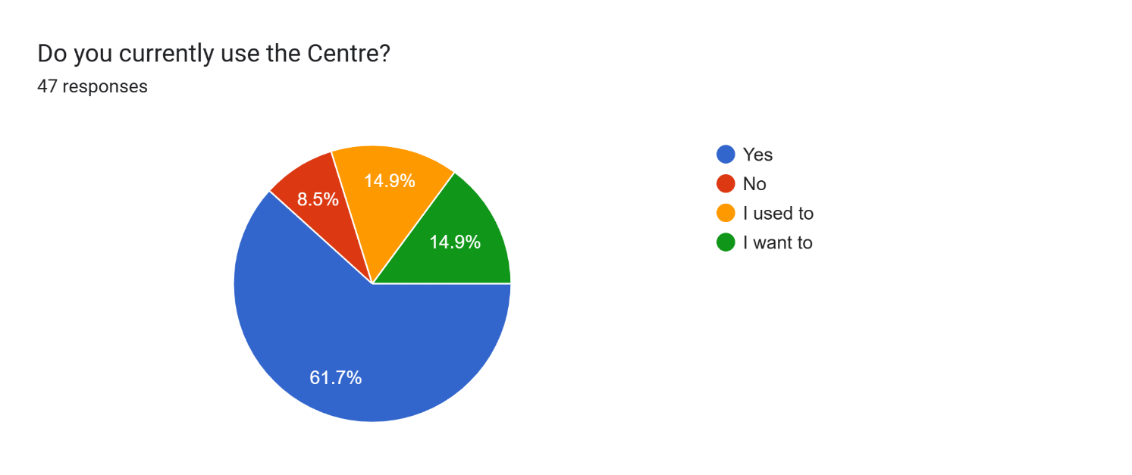

Figure 1: Community Engagement survey question

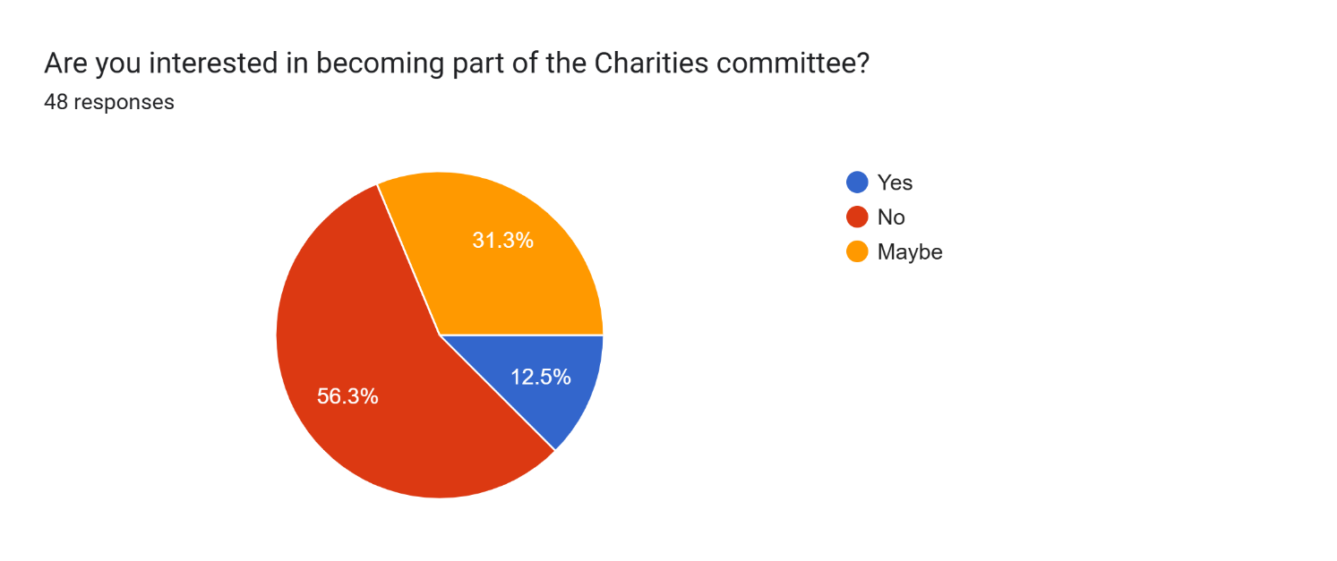

Figure 2: Community Engagement survey question 2

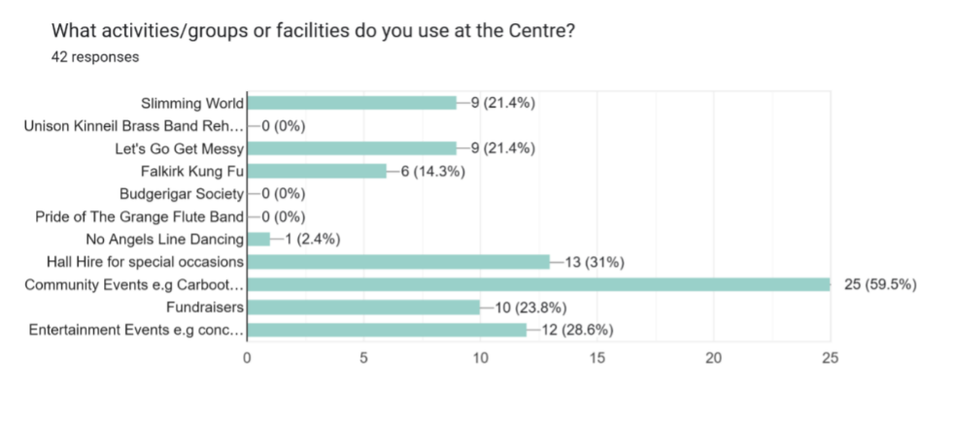

Figure 3: Community Engagement for current usage

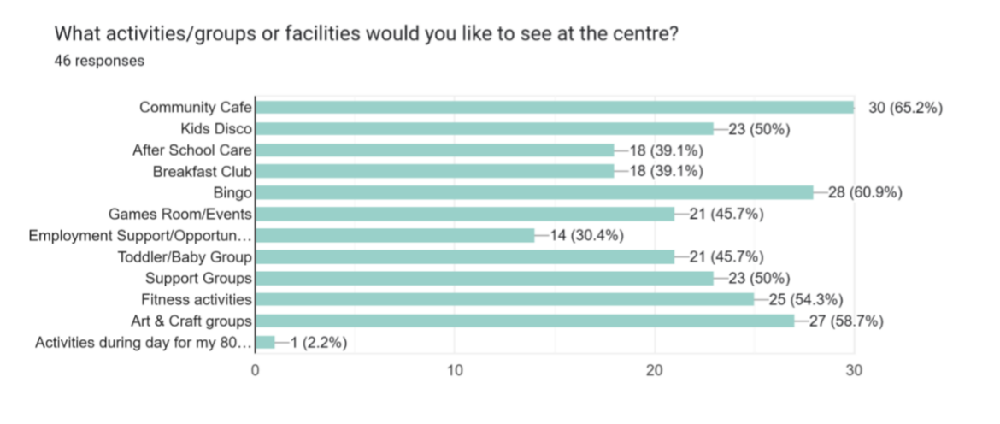

Figure 4: Community Engagement for potential future use

**What do you think the benefits of the building being owned by the community and not the Council would be? Would its use increase?**

‘Yes, if people have ownership they will take pride in it and invest more time and effort in their community’

‘The community benefits loads from small groups and there is no community centers left’

‘Yes, I feel it will be run to its fullest by listening to community wants (this survey for example)’

‘Yes because if not it will be closed and just go to ruin’

‘Yes I do. It's well used and would be a big miss if it were to close’

‘Yes, looking at the hard work that has already been put in by [the] committee and the new ideas going forward I would see the footfall and use increasing and a great benefit to the community.’

‘I think the community can really help as they can build a place for people to meet and support and know what the community would want and be useful’

**Quotes**

‘The Sealock centre provides a centre location next to transport and schools making it the ideal location for us to be based. It has a main hall and several other rooms which allow meetings with parents when needed in a confidential setting. The space is warm and inviting and the team are extremely helpful and dedicated to enhancing the support and activities offered in their locality.’ – Home-Start

‘I held an event at Sealock Centre on Sunday 26th January 2025. It is a fabulous venue and spotless clean. I dealt directly with [REDACTED] of the Committee, who was very helpful and well organised’. – Centre User

‘The centre came to our rescue last year, when our original meeting room and show hall in Grangemouth closed suddenly. We were fortunate enough to find Newlands community centre where we received a warm welcome. We have since been able to continue our meetings which involve all age groups in our hobby. We look forward to the improvements they want to make in the future which will be a great asset to us and the area.’ - Forth Valley Budgerigar Society and The Scottish Budgerigar Society

Letters of Support (A full list can be found in the appendix):

Figure 5: Letter of Support from One Parent Families Scotland

5.1.2 Have you consulted with other local stakeholder groups or agencies? Please provide evidence.

We have attended CVS Falkirk & District’s Community Ownership Group meetings which has put us in contact with other community groups going through the Community Asset Transfer process. We are in close contact with several community groups in Grangemouth.

5.1.4 Have you been in contact with any other communities or community groups

that may be affected? Please give details.

We have attended several meetings hosted by other community groups interested in taking community ownership of their community space. We have assisted other groups in the Grangemouth area to help with their Community Asset Transfer applications. We have engaged extensively with the community, our current users and potential future users of the centre. Evidence of this engagement can be found in our appendices.

5.1.5 Please provide any other information you think may be relevant.

1. **Financial Viability of Project**

Your Business Plan should contain full information about the financial viability of the project, evidencing that the organisation will be able to sustain the project in the long term.

Please submit

* at least 1 year’s audited accounts to evidence your organisations financial stability (if available)
* where audited accounts are not available (for instance for new groups) please provide a bank statement.
* a projected 5 year income and expenditure account
* a cash flow forecast for the proposed asset transfer.

|  |
| --- |
| 6.1 Please outline the Policies and Procedures your organisation has in place to govern the group’s finances  We recognise our organisation’s requirements as a registered SCIO. We will continue to submit audited accounts yearly to OSCR. Our finances are presented and scrutinised at every board meeting. We will follow OSCR’s [Guidance and Good Practice for Charity Trustees (oscr.org.uk)](https://www.gov.scot/binaries/content/documents/govscot/publications/advice-and-guidance/2017/01/asset-transfer-under-community-empowerment-scotland-act-2015-guidance-community-9781786527509/documents/00513211-pdf/00513211-pdf/govscot:document/00513211.pdf) to ensure we manage our finances correctly.  We have set rates for each of our spaces available to let and will review these yearly at our AGM.  We have a Financial Policy for our group.  A copy of our 5-year cash flow projection can be found in our appendices. |

1. **Funding**
   1. Please outline how you propose to fund the price or rent you are prepared to pay for the land, and your proposed use of the land.

If you intend to apply for grants or loans you should demonstrate that your proposals are eligible for the relevant scheme, according to the guidance available for applicants*.*

7.1.1 Please show your calculations of the costs associated with the transfer of the land or buildings and your future use of it, including any redevelopment, ongoing, maintenance and the costs of your activities. All proposed income and investment should be identified, including volunteering and donations.

We recognise we will be required to instruct a solicitor to review and negotiate the terms of our purchase, conclude missives, and conduct the conveyance. We will continue to seek further funding in the future.

We have gathered quotes from contractors and Business Energy Scotland have carried out a survey on our building to give us costs for the redevelopment of the centre, as well as energy efficiency improvements we plan to carry out.

Please see our Cash Flow for all our planned start up, ongoing, maintenance and planned redevelopment costs. Our Cash Flow also shows all proposed income and investment.

We have carried out extensive checks on the prices being charged by my main competitors and have based our prices on being competitive with them. The attached Financial Appendices show that this pricing structure will allow SeaLock Infinity to have an income less expenditure build a viable business.

Current Operating Times - 7 days per week 8am until 11.30pm or by arrangement for Weekend opening hours

Charges will remain unchanged in 2025-2026 which is competitive with other community buildings.

We are looking at the possibility of the introduction of a membership fee. If implemented, we will look at a member’s benefit package scheme. This would give all our members the opportunity to become more involved with the running of the centre. This will also give them access to a member benefit package scheme. Any decision will be consulted on with the membership and decision will be taken at our Annual General Meeting (AGM) or by calling an Extraordinary General Meeting (EGM) for that purpose.

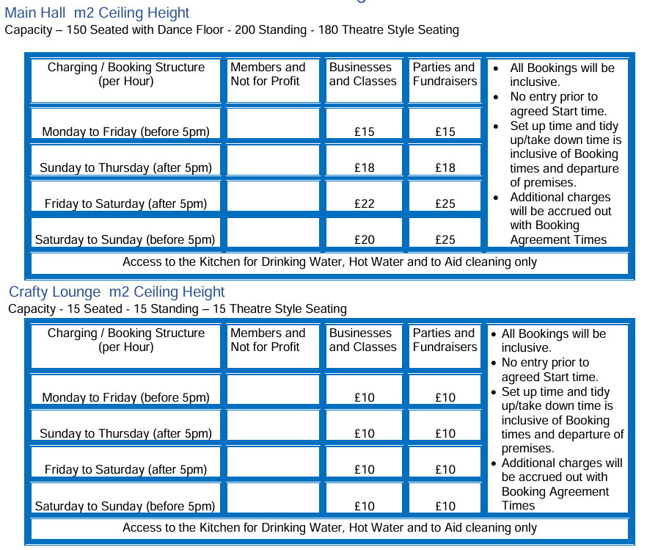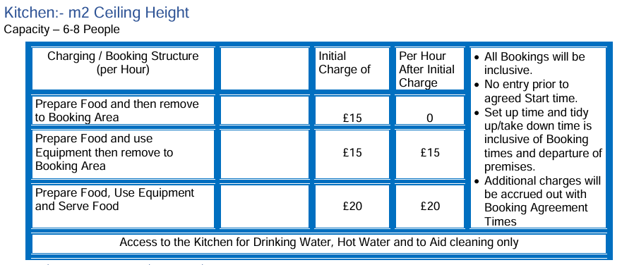

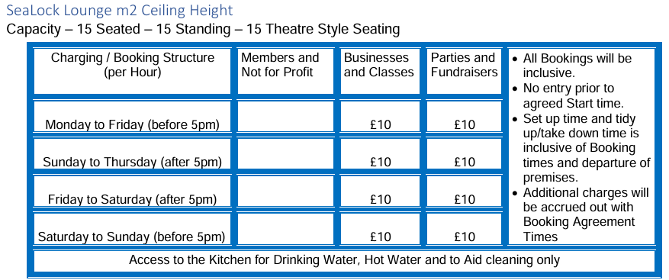

Our forecasts for 2025/2026 are based on the services that we provide, with a revised increase in the let price which will be agreed upon at our AGM.

Our board of trustees/volunteer hours projected for the next 5 years:

VOLUNTEER HOURS

7.1.2 Please supply details of what funding you have received so far, and of any conditions attached to it.

We have secured funding through Falkirk Council’s Community Empowerment Grant and their Capital Equipment Grant.

7.1.3 Please supply details of any funding you have applied for but have not yet received a response or decision. Please include timescales if known.

We have applied for Falkirk Council’s Community Choices and will hear back on the 28th of March 2025.

Business Energy Scotland and Local Energy Scotland who manage CARES

7.1.4 Details of any other funding you will have access to? i.e. voluntary contributions, borrowing etc.

We have outlined our request for Falkirk Council’s Enablement Fund as part of the Community Asset Transfer.

National Lottery Awards for All, Wee Grants – The Robertson Trust, (SLCF, Scottish Landfill Communities Fund

Some of the funding you have to be trading a least 12 months and published accounts before you can apply.

7.1.5 Please outline your funding strategy if you have one, as well as any other relevant information.

We recognise that there is a need to continually update and upgrade our facilities, and we keep up to date with the various funding opportunities available to us, thanks to our local third sector interface, CVS Falkirk & District.

1. **Enablement Fund**

Falkirk Council will hand the building over wind and watertight and compliant. However, this is quite light-touch and would involve (for example) patching of a leaky roof. For more significant building works, groups can apply to the Enablement Fund, to pay for capital improvements such as energy efficiency improvements or larger capital renewals which support the viability of the project going forward. **Only capital items are eligible**. Running repairs are revenue costs and are not eligible. You are strongly advised to email [strategicpropertyreview@falkirk.gov.uk](https://www.oscr.org.uk/media/3621/v10_guidance-and-good-practice-for-charity-trustees.pdf) to confirm eligibility criteria before you submit this application.

Requests to the Fund must be supported by estimates / quotations from professionals which should be provided as supporting documents.

**Please provide details of your request to the Enablement Fund, if applicable.**

|  |
| --- |
| **Enablement Fund request for larger capital renewals which support the viability of the CAT** |

[REQUESTS REDACTED]

**Checklist of accompanying documents**

To check that nothing is missed, please tick which additional documents are accompanying this form.

Section 1 – You must attach your organisation’s constitution, articles of association or registered rules

Section 2 – Any maps, drawings or description of the land requested

Section 3 – Note of any terms and conditions that are to apply to the request

Section 4 – Any additional evidence regarding your proposals, their benefits, any restrictions on the land or potential negative consequences, and your organisation’s capacity to deliver.

Section 5 – Evidence of community support

Section 6 – Financial – Copies of accounts, forecasts, etc

Section 7 – Funding – Copy of Business Case etc

Section 8 – Enablement Fund – copies of estimates

**Declaration**

Two office-bearers (board members, charity trustees or committee members) of the community transfer body must sign the form. They must provide their full names and home addresses for the purposes of prevention and detection of fraud.

This form and supporting documents will be made available online for any interested person to read and comment on. Personal information will be redacted before the form is made available.

**We, the undersigned on behalf of the community transfer body as noted at Section 1, make an asset transfer request as specified in this form.**

**We declare that the information provided in this form and any accompanying documents is accurate to the best of our knowledge.**

Name [REDACTED]

Address [REDACTED]

Date 17/03/2025

Position Chair of the Board of Trustees for SeaLock Infinity

Signature [REDACTED]

Name [REDACTED]

Address [REDACTED]

Date 17/03/2025

Position Secretary to the Board of Trustees for SeaLock Infinity

Signature [REDACTED]